The road to HIPAA Compliance
B2B Weekend 1 Project
Adrian Joco- Network Engineer
Mariah Rodgers- Security Manager
Diamond Williams- Project Manager
For the physical devices in the room:
West office: VLAN 10 & 20, using Switch 1 in the rack
East office: VLAN 10, using Switch 2 in the rack
Accounting office: VLAN 10, using switch 3 in the rack
West office: PC1 (VLAN 10)- Fa0/1-12, PC2 (VLAN 20)- Fa0/12-24
East office: PC3 (VLAN 10)- Fa0/1-12, PC4 (VLAN 20)- Fa0/12-24
Accounting office: PC5 (VLAN 10)- Fa0/25-48
Router 1(West), Router 2(East) & Router 3(Accounting)
S0/1/0 to S0/1/1, S0/1/0 to S0/1/1, S0/1/0 to S0/1/1
West (R1) G0/1 to West Switch (Sw1) G0/0/1
Diamond: Things I looked up to make the network more compliant/better.

What is needed to make our network more HIPAA compliant
✔ Segmented VLANs
✔ Server isolation
✔ Encrypted traffic
✔ Controlled wireless access
✔ Logging & accountability
✔ Reliable infrastructure
Ideally, you would have:
• VLAN 10 – Clinical Staff (Doctors & Nurses)
• VLAN 20 – Staff
• VLAN 30 – Servers (EHR / Patient Records)
• VLAN 40 – Employee BYOD
• VLAN 50 – Guest / Patient Wi-Fi (Internet only)
Static IPs for server, firewall
DHCP for doctors, staff, patients
Mobile Device Management (BYOD)
ACLs for routers based on vlan groups
Employee Wi-Fi should not be broadcasted
TACACS/RADIUS server authentication

Adrian’s cost analysis for the hypothetical expansion of the current network:
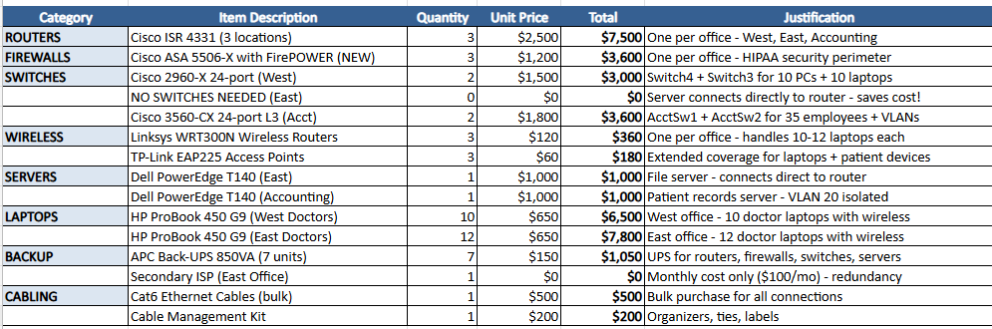
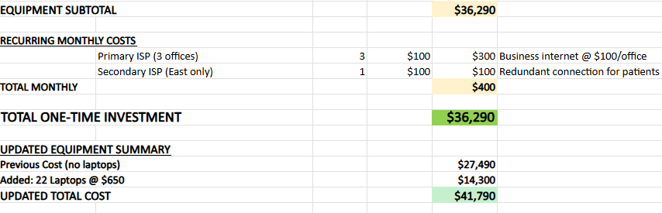
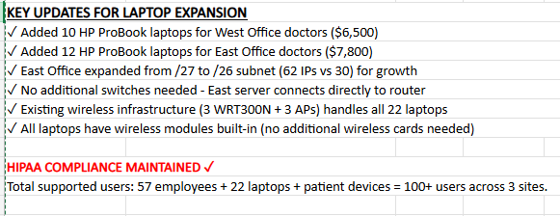

Cost analysis breakdown:
1. ROUTERS - Cisco ISR 4331 ($7,500 for 3)
- Has 3 built-in ports (no expensive add-ons)
- Supports VPN tunnels between offices (HIPAA needs this)
- Handles 50+ users easily per router
- Industry standard, easy to get help
2. FIREWALLS - Cisco ASA 5506-X ($3,600 for 3)
- HIPAA legally requires firewalls to protect patient data
- Blocks hackers and malware automatically
- We bought NEW (not refurbished) because medical offices need warranty for liability
- One per office to protect each internet connection
3. SWITCHES - Only 4 switches ($10,600)
- West: 2 switches for 10 PCs + laptops ($3,000)
- East: ZERO switches - server plugs directly into router! SAVES $3,000+
- Accounting: 2 Layer 3 switches for VLANs to isolate patient data ($3,600)
4. WIRELESS - 3 routers + 3 APs ($540)
- Budget-friendly but reliable for offices
- Handles all 22 laptops + patient WiFi + BYOD
- WPA2 encryption (secure wireless)
- Capacity: 300+ devices (we only need 52)
5. SERVERS - Dell PowerEdge T140 ($2,000 for 2)
- Real servers (not desktops) - designed for 24/7 operation
- One for East file sharing, one for Accounting patient records
- Has encryption for HIPAA compliance
6. LAPTOPS - HP ProBook 450 G9 ($14,300 for 22)
- Doctors need to move between exam rooms
- Business-class = durable with warranty
- Built-in encryption chip (HIPAA requirement)
- 10 for West, 12 for East
7. UPS Battery Backup ($1,050 for 7)
- Protects equipment from power surges
- 10-15 minutes backup (enough to shut down safely)
- Way cheaper than enterprise UPS (saves $1,750)
8. CABLING ($700)
- Bulk Cat6 cable = way cheaper than pre-made
- Cable management makes it look professional

Diamond’s talking notes:
We are upgrading their routers, and this change will better secure the whole network.
The low latency issue should be resolved as well by all the upgrades being made.
Automatic log off periods
Logs
The network will now have VLAN segmentations.

West off router
Dr vlan 10 - 2 / 30 users – g0/0/0.10
staff vlan 20 – 10 / 14 users
Server vlan 30 – 2 / 2 users
ASA – 2/2 user 255.255.255.252 /30
S0/1/0 - connects to east office
S0/1/1 - connects to accounting

East off router
Dr vlan 10 – 2 / 30 users – g0/0/0.10
Staff vlan 20 – 12 /14 users + 1 printer
Server vlan 30 – 2 / 2 users
Guest wifi – 32 users available - g0/0/1
ASA – 2/2 user 255.255.255.252 /30
Staff wifi -
S0/1/0 - connects to accounting
S0/1/1 - connects to west

Acct router
Staff vlan 10 - 35 / 64 users + 2 printers
staff wifi – / 64 users
S0/1/0 - connects to west
S0/1/1 - connects to east

hostname westoffice
int g0/0/0.10
encap dot1q 10
ip add 10.24.1.1 255.255.255.224
int g0/0/0.20
encap dot1q 20
ip add 10.24.1.33 255.255.255.224

hostname eastoffice
int g0/0/1.10
encap dot1q 10
ip add 10.24.2.1 255.255.255.248
WEST DHCP
ip dhcp pool drpool
network 10.24.1.0 255.255.255.224
default-router 10.24.1.1
dns-server 11.1.1.10
Ip dhcp excluded-address 10.24.1.1
ip dhcp pool staffpool
network 10.24.1.32 255.255.255.224
default-router 10.24.1.33
dns-server 11.1.1.10
Ip dhcp excluded-address 10.24.1.33
EAST DHCP
ip dhcp pool patientwifi
network 10.24.8.0 255.255.255.224
default-router 10.24.8.1
dns-server 11.1.1.10
dhcp excluded-address 10.24.8.1

ip dhcp pool eastpool
network 10.24.2.0 255.255.255.224
default-router 10.24.2.1
dns-server 11.1.1.10
dhcp excluded-address 10.24.2.1
ACCT DHCP
ip dhcp pool acctpool
network 10.24.3.0 255.255.255.192
default-router 10.24.3.1
dns-server 11.1.1.10
ip dhcp excluded-address 10.24.3.1

#configuring OSPF on routers
router ospf 1
network 10.24.1.0 0.0.0.31 area 1
network 10.24.1.32 0.0.0.31 area 1
Network 10.24.10.0 0.0.0.3 area 1
network 10.24.10.4 0.0.0.3 area 1
network 10.24.10.8 0.0.0.3 area 1
R1(config-router)#network 10.97.3.0 0.0.0.3 area 2

R2(config)#router ospf 1
R2(config-router)#network 10.97.1.0 0.0.0.127 area 3
R2(config-router)#network 10.97.1.128 0.0.0.63 area 3
R2(config-router)#network 10.97.1.192 0.0.0.31 area 3
R2(config-router)#network 10.97.1.224 0.0.0.15 area 3
R2(config-router)#network 10.97.5.0 0.0.0.3 area 0
R2(config-router)#network 10.97.5.0 0.0.0.3 area 0
R2(config-router)#network 10.97.5.4 0.0.0.3 area 0

R3(config)#router ospf 1
R3(config-router)#network 10.97.2.0 0.0.0.63 area 4
R3(config-router)#network 10.97.2.64 0.0.0.63 area 4
R3(config-router)#network 10.97.2.128 0.0.0.63 area 4
R3(config-router)#network 10.97.2.192 0.0.0.63 area 4
R3(config-router)#network 10.97.5.4 0.0.0.3 area 0
R3(config-router)#network 10.97.5.8 0.0.0.3 area 0

#run on each router
ping 11.1.1.10
show ip route

This would be for the hypothetical network
Commands we can use for port security on switches from a previous assignment.
#place port security on switches
int range f0/1-24
switchport port-security
switchport port-security maximum 1
switchport port-security mac-address sticky
switchport port-security violation restrict

Implementing switch port security helps prevent unauthorized devices from accessing the network by limiting which devices can connect to specific switch ports. This reduces insider threats, protects against MAC-based attacks, and helps ensure that only approved systems can access networks containing protected health information, supporting HIPAA security requirements.
Where to implement port security:
- Staff desktop ports
- Server-facing switch ports
- Office wall jacks in exam rooms
- NOT recommended on guest Wi-Fi uplinks or trunk ports

🔷 IP ADDRESSING & SUBNETTING
"Why did you choose /27, /26, and /30 subnet masks?"

Answer: /30 for point-to-point (serial links), /27 for small LANs (30 hosts), /26 for larger office (62 hosts)

"How many usable IP addresses do you have in each subnet?"

/30 = 2 usable, /27 = 30 usable, /26 = 62 usable

"What's the broadcast address for 10.24.1.0/27?"

Answer: 10.24.1.31

Medium Questions:
4. "Why did you use 10.24.x.x addressing? Why not 192.168.x.x?"

Answer: 10.0.0.0/8 gives us more flexibility for growth, still RFC 1918 private

"Walk me through how a packet gets from WestPC1 to EastPC1."

Answer: WestPC1 → WestSwitch (VLAN 10) → WestOffice router → routes to 10.24.2.0 via serial to EastOffice → EastSwitch (VLAN 10) → EastPC1

🔷 ROUTING
Easy Questions:
6. "What routing protocol are you using?"

Answer: Static routing (show the ip route commands)

"Why static routing instead of dynamic (RIP, OSPF, EIGRP)?"

Answer: Small network (3 routers), predictable topology, simpler to manage and troubleshoot

Medium Questions:
8. "What happens if the link between West and East goes down?"

Answer: Traffic can reroute through Accounting router (triangle topology provides redundancy)

"Show me your routing table. How does WestOffice know where 10.24.2.0/27 is?"

Answer: Static route: ip route 10.24.2.0 255.255.255.0 10.24.10.2

Hard Question:
10. "Why didn't you use default routes on all routers?"
- Answer: Only AcctOffice and branch offices use default routes pointing toward firewall/internet. Inter-office traffic uses specific static routes.

🔷 DHCP
Easy Questions:
11. "Why use DHCP instead of static IPs for end devices?"
- Answer: Easier management, less configuration errors, scalable

"What IP range did you exclude from DHCP and why?"

Answer: .1-.9 in each subnet for network devices (routers, servers, printers that might need static IPs)

Medium Questions:
13. "Where is the DHCP server located?"
- Answer: Each router acts as DHCP server for its local VLANs (distributed DHCP)

"What happens if a device on VLAN 10 can't get a DHCP address?"

Answer: Check router DHCP pool config, verify VLAN trunk is working, check switch port VLAN assignment

🔷 VLANs
Easy Questions:
15. "Why did you use VLANs?"
- Answer: Segment traffic by department (doctors vs staff), reduce broadcast domains, improve security

"What's the difference between an access port and a trunk port?"

Answer: Access = one VLAN, connects end devices. Trunk = carries multiple VLANs, connects switches to routers

Medium Questions:
17. "Why does West have VLAN 10 and 20, but Accounting only has VLAN 10?"
- Answer: West separates doctors/nurses from staff. Accounting is smaller, everyone in one VLAN simplifies management

"How does inter-VLAN routing work?"

Answer: Router-on-a-stick using subinterfaces (G0/0/0.10, G0/0/0.20) with dot1Q encapsulation

Hard Question:
19. "Could you use a Layer 3 switch instead of router-on-a-stick?"
- Answer: Yes, but for this small network, router-on-a-stick is simpler and meets requirements

🔷 TOPOLOGY & DESIGN
Easy Questions:
20. "Why did you use a triangle topology for the serial connections?"
- Answer: Redundancy - if one link fails, traffic can reroute through the third router

"Why serial connections between routers instead of Ethernet?"

Answer: Simulates WAN links (realistic for multi-site), uses serial for learning purposes

Medium Questions:
22. "Why is Accounting the hub instead of making it a full mesh?"
- Answer: Accounting has firewall/internet connection, central location makes sense for default routing

"How would your design scale if they added a 4th office?"

Answer: Add another router with serial connections, add static routes to all routers, extend addressing plan

Hard Question:
24. "What's a single point of failure in your design?"
- Answer: The firewall at Accounting - if it fails, no internet access (would need redundant firewall/ISP for production)

🔷 TROUBLESHOOTING
Common Questions:
25. "WestPC1 can't ping EastPC1. Walk me through your troubleshooting steps."
- Answer:
1. Check WestPC1 IP config (DHCP working?)
2. Ping default gateway (10.24.1.1)
3. Check VLAN assignment on switch port
4. Check router routing table
5. Ping next hop (serial interface)
6. Check destination router/switch/PC

"A user complains internet is slow. How do you isolate the problem?"

Answer:

Check local PC connectivity
Ping default gateway
Ping firewall (10.24.10.14)
Check router interface utilization
Check for broadcast storms (VLAN issues)

"Show me how you would verify DHCP is working."

Answer:

show ip dhcp binding (on router)
show ip dhcp pool
Check PC: ipconfig/ifconfig

🔷 DOCUMENTATION & BEST PRACTICES
Questions:
28. "Why did you document your IP addressing in a table?"
- Answer: Easy reference, prevents IP conflicts, helps with troubleshooting, required for any production network

"What would you do differently if this was a production network?"

Answer:

Use dynamic routing (OSPF)
Add redundant firewall/ISP
Implement monitoring (SNMP)
Add more VLANs for better segmentation
Document cable labeling
Create network diagrams

"How would you document changes to this network?"

Answer: Update IP table, update topology diagram, configuration backups, change log

